BIT 4107 – Mobile Application Development
STUDENT LOGBOOK
Weeks 6 & 7 – Networking, APIs & Application Architecture
Project: SpareDash – Kenyan Automotive Spare Parts Platform
Student Name | Newton kariithi
Admission Number | BIT/2025/31318
School/Faculty | School of Computing and Informatics
Programme | Bachelor of Information Technology (BIT)
Academic Year | 2025/2026
Semester
Unit Code | BIT 4107
Unit Name | Mobile Application Development
Lecturer | MR MICHAEL NYORO

Week 6: Networking and APIs

Topic | Networking and APIs in Flutter
Date | Week 6 – June 2026
Project | SpareDash – Vehicle & Parts Search via REST API
Screenshots Attached | Yes

Learning Objectives
- Understand REST API integration in Flutter mobile applications
- Connect SpareDash to a live external API and display real-time data
- Implement proper HTTP request handling with error states and loading indicators
- Demonstrate networking concepts using the NHTSA (US Vehicle API) free endpoint
- Handle network connectivity detection using the connectivity_plus package

Practical Activities Undertaken
# | Activity | Outcome | Screenshot Label
1 | Added http and connectivity_plus packages to pubspec.yaml | Packages resolved successfully; http 1.6.0 installed | Fig 6.1 – pubspec.yaml with packages
2 | Created VehicleService class in lib/services/vehicle_service.dart | Static methods for getCarMakes() and getModelsByMake() implemented | Fig 6.2 – vehicle_service.dart code
3 | Built VehicleSearchScreen with search field and results list | Screen shows loading spinner, error state, and results list | Fig 6.3 – Vehicle Search screen UI
4 | Searched 'Toyota' on live NHTSA API | 58 Toyota models returned from real API on device | Fig 6.4 – 58 Toyota models live results
5 | Searched 'Nissan' to verify API works for different makes | Nissan models returned correctly from live endpoint | Fig 6.5 – Nissan search results
6 | Created ConnectivityProvider and NetworkBanner widget | Red 'No internet' banner appears when offline; green 'Connected' banner on restore | Fig 6.6 – Network status banner (offline)
7 | Registered ConnectivityProvider in MultiProvider in main.dart | Network status monitored globally across all screens | Fig 6.7 – main.dart MultiProvider setup
8 | Wired Vehicle Search as 6th tab in bottom navigation bar | Vehicles tab accessible from all screens in the app | Fig 6.8 – Bottom nav with Vehicles tab

API Details – NHTSA Vehicle API
API Name | NHTSA Vehicle Products API
Base URL | https://vpic.nhtsa.dot.gov/api/vehicles
Authentication | None required (free, public API)
Endpoint Used | /getmodelsformake/{make}?format=json
Response Format | JSON – Results array with Make_Name and Model_Name fields
Timeout | 10 seconds (implemented in VehicleService)
Error Handling | HTTP status check, timeout catch, 'Try Again' button on failure

Screenshots / Evidence

[SCREENSHOT: Fig 6.3 – Vehicle Search Screen (empty state)]
Show the Vehicle Search screen before any search — search bar + 'Try: Toyota, Nissan, Subaru, Isuzu' hint text
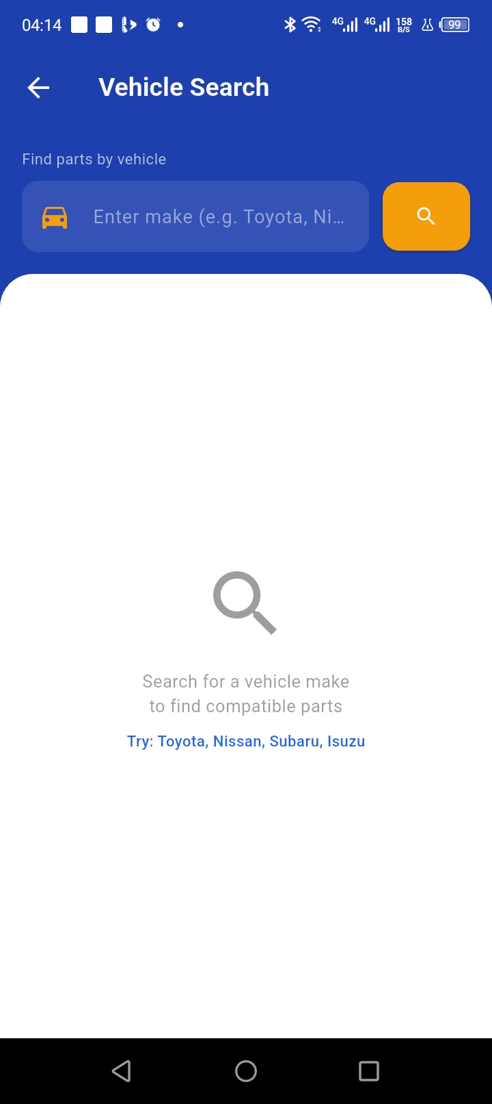

[SCREENSHOT: Fig 6.4 – Toyota Search Results (live API)]
Show '58 models found for Toyota' list on the INFINIX X669 device — proves live API data on a real device
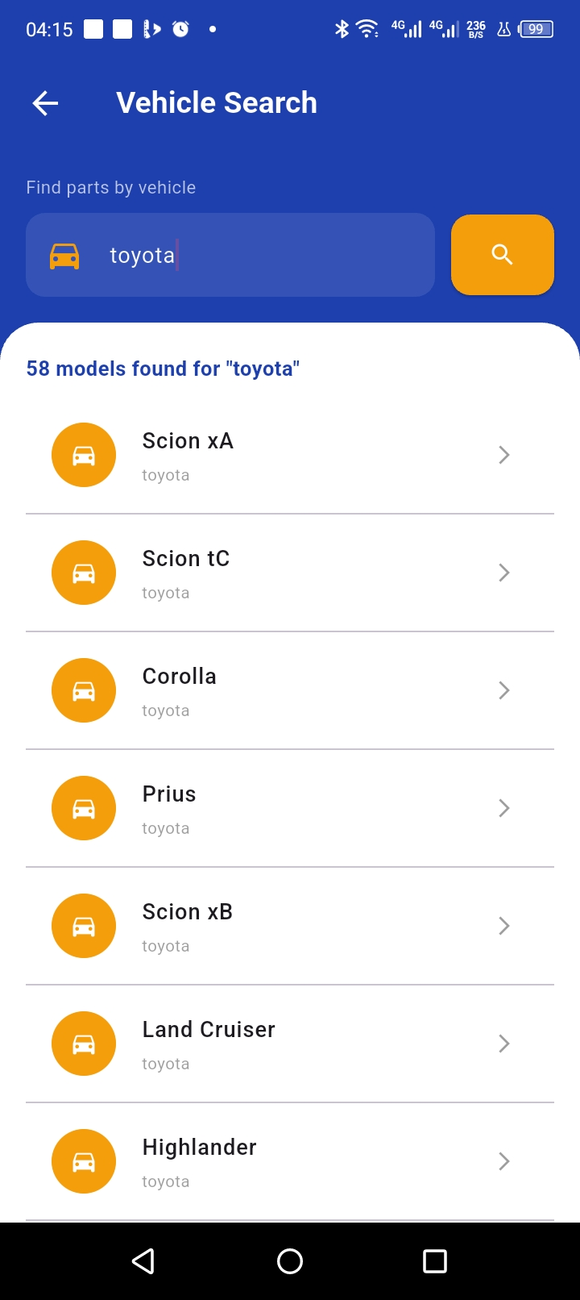

[SCREENSHOT: Fig 6.5 – Nissan Search Results]
Show Nissan models returned from the same API endpoint
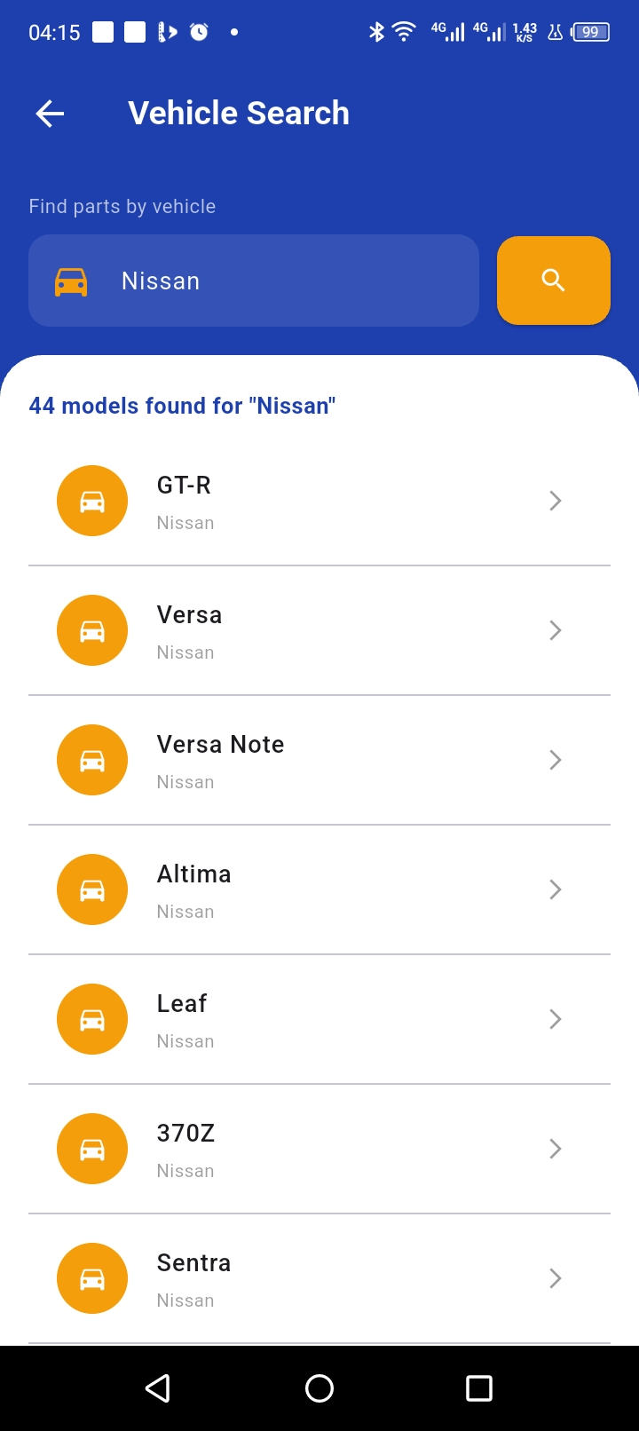

[SCREENSHOT: Fig 6.6 – Network Banner (Offline)]
Turn off WiFi/data, show the red 'No internet connection' banner at top of screen
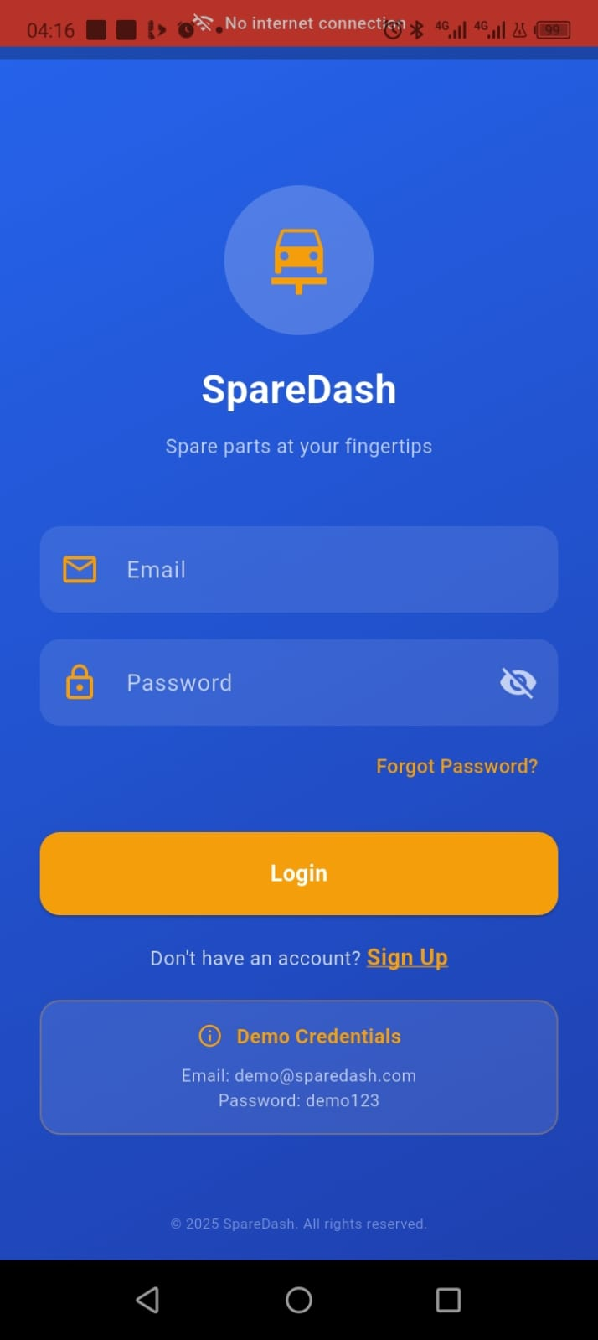

[SCREENSHOT: Fig 6.8 – Bottom Navigation with Vehicles Tab]
Show bottom nav bar with 6 tabs: Home, Catalog, Cart, Ship, Profile, Vehicles
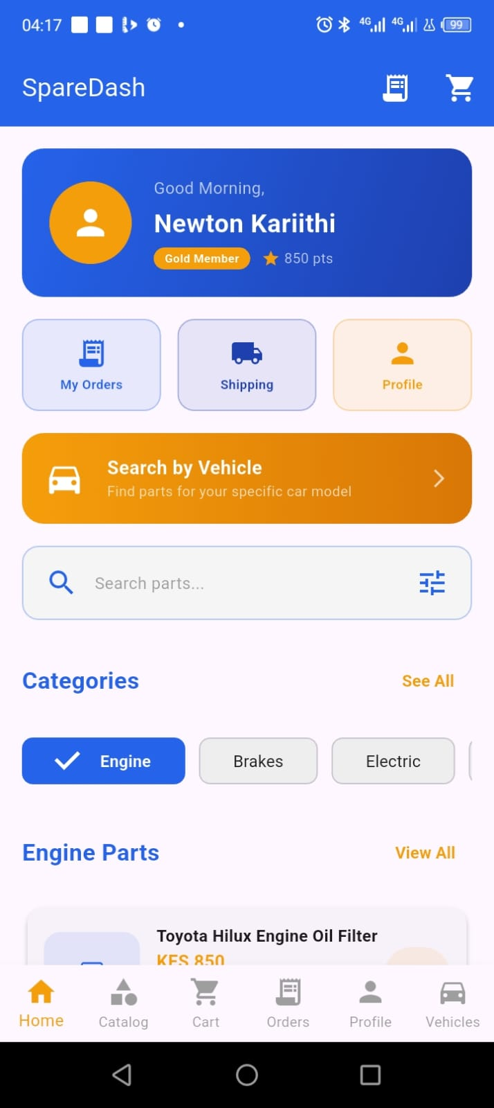

Tools / Software Used
IDE | Android Studio Narwhal (2025.3.4)
Flutter SDK | Flutter 3.44.2 (upgraded from 3.22.0)
Dart SDK | Dart 3.12.2
Test Device | INFINIX X669 (Android, USB debugging enabled)
API | NHTSA Vehicle Products API (free, no key required)
Packages | http: ^1.2.0, connectivity_plus: ^6.0.3, provider: ^6.1.1
Version Control | Git (Android Studio built-in)

Challenges & Solutions
Challenge | Solution
Gradle build failed with 'unable to resolve class groovy.xml.QName' | Upgraded Flutter from 3.22.0 to 3.44.2 using flutter upgrade — resolved Groovy/JDK incompatibility
ListTile ink splash warning inside DecoratedBox | Replaced Container with Material widget for the results area to fix rendering hierarchy
Network banner needed to appear globally on all screens | Wrapped root screen in NetworkBanner widget in main.dart so all screens inherit it

Personal Reflection
Week 6 was a major breakthrough — connecting SpareDash to a live REST API and seeing 58 real Toyota models populate on a physical device proved the networking layer works end-to-end. The connectivity banner adds genuine offline-first behavior, directly matching what Kenyan users need on variable mobile data connections.

Week 7: Application Architecture

Topic | Application Architecture – SQLite, State Management & Order Tracking
Date | Week 7 – June 2026
Project | SpareDash – Local Storage, Provider Pattern & Order Tracking
Screenshots Attached | Yes

Learning Objectives
- Implement local SQLite database storage to persist user data across sessions
- Apply the Provider state management pattern for reactive UI updates
- Design and implement a multi-table database schema (users, parts, orders)
- Build a full CRUD order tracking system with real-time status updates
- Populate the app with realistic Kenyan test data (Nairobi sellers, KES prices)

Practical Activities Undertaken
# | Activity | Outcome | Screenshot Label
1 | Added sqflite and path packages to pubspec.yaml | sqflite 2.4.3 and 5 companion packages installed successfully | Fig 7.1 – pubspec.yaml with sqflite and path
2 | Created DatabaseHelper singleton class with 3 tables: users, parts, orders | Tables created on first launch with demo user and 35+ Kenyan parts seeded | Fig 7.2 – database_helper.dart tables and seed data
3 | Upgraded DatabaseProvider from in-memory Map to real SQLite queries | Login and registration now persist across full app restarts | Fig 7.3 – database_provider.dart using DatabaseHelper
4 | Tested user persistence: registered new account, closed app, re-logged in | New account credentials survived full app restart — SQLite confirmed working | Fig 7.4 – Successful login with SQLite-persisted account
5 | Seeded 35+ Kenyan parts with real Nairobi sellers and KES prices | Parts show sellers like 'Kamau Auto Spares – Kirinyaga Road' with realistic prices | Fig 7.5 – Home screen showing Kenyan parts data
6 | Updated SimpleHomeScreen to load parts from SQLite instead of hardcoded data | Category chips dynamically query SQLite; real seller names and locations displayed | Fig 7.6 – Home screen with live SQLite parts
7 | Built OrderTrackingScreen with 4-step progress tracker (Pending → Processing → Shipped → Delivered) | Orders display in cards with status update buttons and delete confirmation | Fig 7.7 – Order Tracking screen with order cards
8 | Updated CartScreen checkout to write each item to SQLite orders table | Checkout saves real orders; 'Track Order' button navigates to tracking screen | Fig 7.8 – Order confirmed dialog with Track Order button
9 | Added Orders tab (index 3) to bottom navigation bar | Orders accessible from every screen via bottom nav | Fig 7.9 – Bottom nav with Orders tab

Database Schema
Table | Columns
users | id (PK), name, email (UNIQUE), password, created_at
parts | id (PK), name, category, price, price_value, in_stock, rating, seller, location
orders | id (PK), user_email, part_name, quantity, total_price, status, seller, location, created_at

Provider Architecture
Provider | Responsibility
CartProvider | Manages cart items, quantities, subtotal, delivery fee, total — in-memory during session
DatabaseProvider | Handles SQLite login, registration, order placement — persists across restarts
ConnectivityProvider | Monitors real-time network status (WiFi / mobile data / offline)

Screenshots / Evidence

[SCREENSHOT: Fig 7.5 – Kenyan Parts Data]
Show parts cards with 'Kamau Auto Spares – Kirinyaga Road' or similar real Nairobi seller names and KES prices
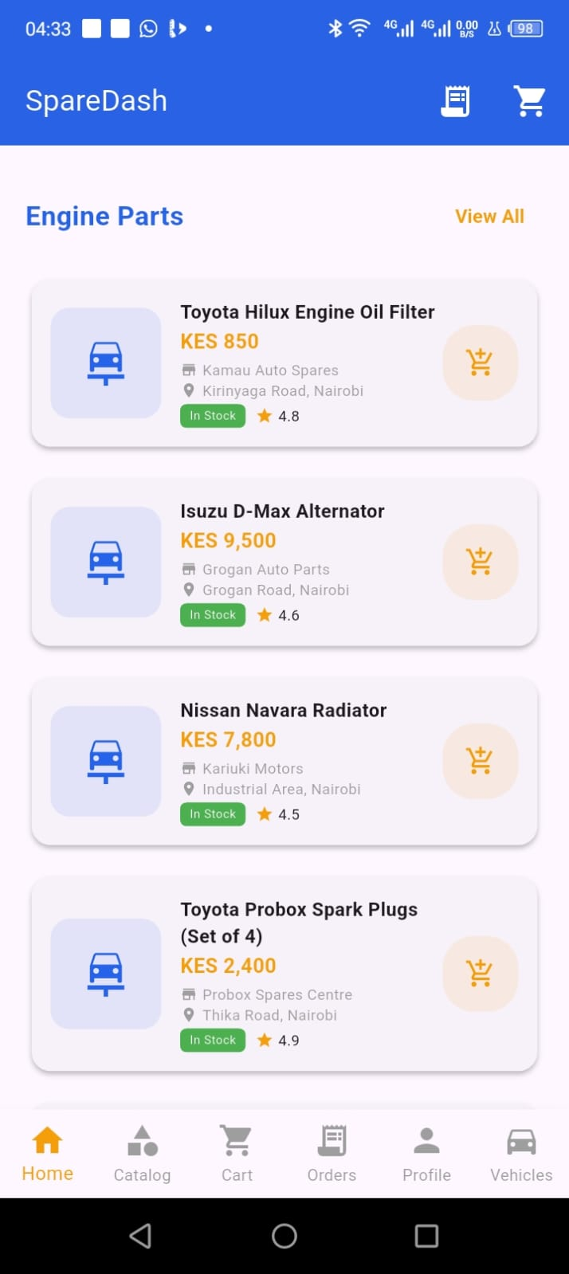

[SCREENSHOT: Fig 7.6 – Home Screen with SQLite Parts]
Show home screen with Engine category selected, displaying SQLite-loaded parts with seller and location


[SCREENSHOT: Fig 7.7 – Order Tracking Screen]
Show the Order Tracking screen with at least one order card showing the 4-step progress bar
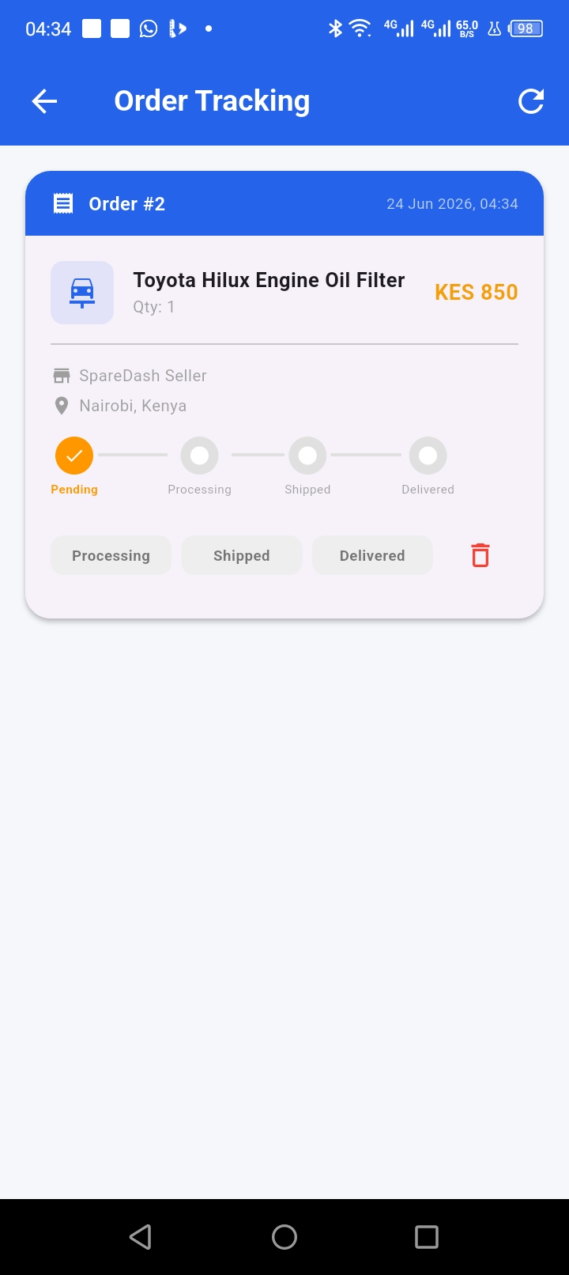

[SCREENSHOT: Fig 7.8 – Checkout with Track Order]
Show the 'Order Confirmed!' dialog with both 'Home' and 'Track Order' buttons
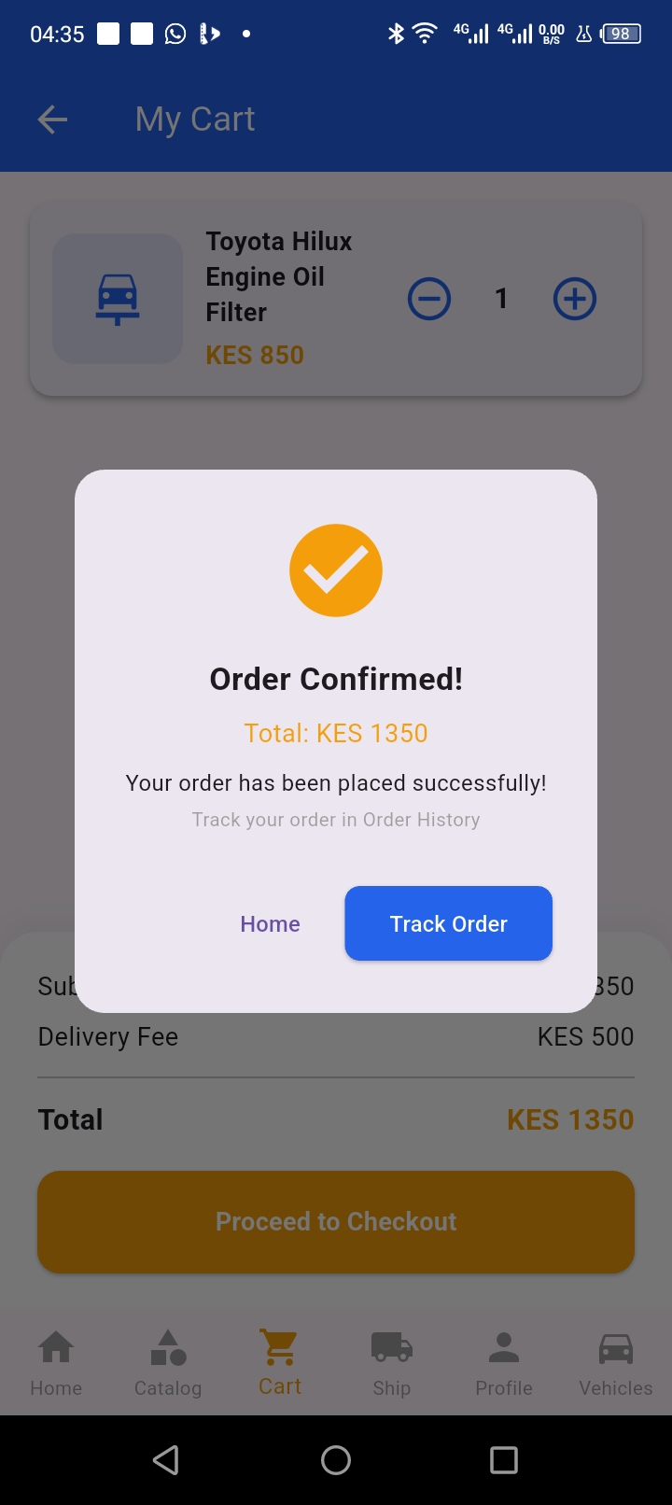

Tools / Software Used
IDE | Android Studio Narwhal (2025.3.4)
Flutter SDK | Flutter 3.44.2
Dart SDK | Dart 3.12.2
Database | SQLite via sqflite 2.4.3
State Management | Provider pattern (ChangeNotifier)
Test Device | INFINIX X669 (Android, USB debugging)
Packages | sqflite: ^2.3.3, path: ^1.9.0, provider: ^6.1.1

Challenges & Solutions
Challenge | Solution
New user registration failed to log in after app restart | Fixed email case sensitivity — normalized all emails to .toLowerCase() in both registerUser() and loginUser() methods
Kenyan parts data not showing after DatabaseHelper update | Bumped database version from 1 to 2 with onUpgrade callback to DROP and recreate tables with new seed data
Home screen still showing hardcoded parts despite SQLite upgrade | Replaced hardcoded _partsByCategory Map with async _loadParts() method that queries DatabaseHelper.instance.getPartsByCategory()
OrderTrackingScreen import conflict with CartScreen | Removed accidental cart_screen.dart import from order_tracking_screen.dart — kept only 4 required imports

Personal Reflection
Week 7 transformed SpareDash from a prototype into a data-driven app. Implementing SQLite with real Kenyan data — Kamau Auto Spares on Kirinyaga Road, Subaru Specialists on Ngong Road — made the app feel genuinely local. The order tracking screen with live status updates completes the core user journey from search to delivery confirmation.

Logbook Sign-off

